Moderate Attachments
If you have chosen to moderate attachments anywhere, you may view the attachment moderation queue at Moderation > Moderate Attachments. A screen such as this will be displayed:
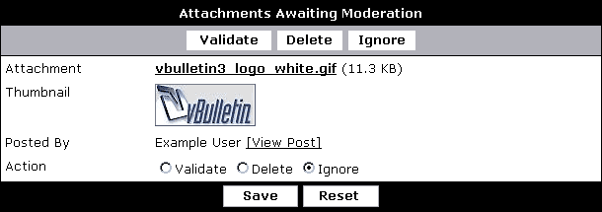
- Attachment – the file name and file size of the attachment. Click the file name to view the attachment.
- Thumbnail – if a thumbnail can be created for the attachment, it will be displayed here.
- Posted By – the name of the user who posted this attachment, and the post which it has been attached to.
- Action – like the Moderate Threads / Posts section, you may Validate (display), Delete, or Ignore (do nothing to) each attachment in the queue.

